EE084IU
Micro-processing Systems Lab

LAB 1

General Digital Input-Output
C and Assembly Programming

Student name: Đỗ Minh Duy
Student ID: ITITSB22029
Class: S1_2024-25-Group01
Date: 19/10/2024

OBJECTIVES
After finishing this lab, students can use AVRStudio software in creating, debugging a project and testing result by downloading the compiled project in to Multi-microcontroller Kit
EQUIPMENT REQUIRED
- Computer
- AVRStudio software, Proteus Simulation
- Burn-E software and Programming Circuit
- Multi-microcontroller Kit
LAB PROCEDURE
Problem 1: Follow step by step the AVRStudio tutorial to create a new project and carry out the simulation
Check point:
 | Signature of Lab Instructor | Remarks
Experiment Run in AVR Studio

Problem 2: List contents of the related registers and SREG (Status) register (C,H,Z) for each line of the following program.
For home work lab report activity, translate each line of this program into binary machine code.
.include "m32def.inc" ; this file provides map of the ATmega32 processor
ldi r16, low(ramend) ; load low byte of RAMEND into r16
out spl, r16 ; store r16 in stack pointer low
ldi r16,high(ramend) ; load high byte of RAMEND into r16
out sph, r16 ; store r16 in stack pointer high
ser r20 ; R20 = 0xFF, C=0,H=0,Z=0
dec r20 ; R20 = 0xFE, C=0,H=0,Z=0
dec r20 ; R20 = 0xFD, C=0,H=0,Z=0
subi r20, -7 ; R20 = -3-(-7)= 4 = 0x04, C=0,H=0,Z=0
inc r20 ; R20 = 0x05, C=0,H=0,Z=0
neg r20 ; R20 = 0xFB, C=1,H=1,Z=0
com r20 ; R20 = 0x04, C=1,H=1,Z=0
clr r20 ; R20 = 0x00
ldi r20,0x77 ; R20 = 0x77, C=1,H=1,Z=1
ldi r21,0x33 ; R21 = 0x33, C=1,H=1,Z=1
ldi r22,0xAA ; R22 = 0xAA, C=1,H=1,Z=1
Ldi r23,0xEE ; R23 = 0xEE, C=1,H=1,Z=1
add r20,R22 ; R20 = R20 + R22, C=1,H=1,Z=0
adc r22,R23 ; R22 = R22 + R23, C=1,H=1,Z=0
adc r21,r20 ; R21 = R21 + R20, C=0,H=1,Z=0
push r22 ; Stack: r22 = 0x9F
push r21 ; Stack: r21 = 0x45
Pop r22 ; R22 = 0x9F
Pop r21 ; R21 = 0x45
Here : jmp here
Check point:
 | Signature of Lab Instructor | Remarks
Experiment Run in AVR Studio

Problem 3 : Give the comment for eachline of the program, Draw the flow chart for following program, explain the function of this program. Simulate and Run to test this code in Proteus. For home work lab report activity, translate each line of this program into binary machine code.

Flow chart:

Explain:
.ORG 00
LDI R18,0xFF ; R18 = 0xFF | 1110 0011 10010 1111 1111 | 0xE3 0x9F
OUT DDRC, R18 ; DDRC = 0xFF | 1011 1001 10010 001010 | 0xB9 0x2A
LDI R16, 15 ; R16 = 15 | 1110 0000 10000 0000 1111| 0xE0 0x0F
LDI R17, 0 ; R17 = 0 | 1110 0000 10001 0000 0000 | 0xE0 0x10
L1: ADD R17,R16 ; R17 = R17 + R16 | 0000 1101 10001 10000 | 0x1C 0x10
DEC R16 ; R16 = R16 – 1 | 1001 0100 10000 0000 | 0x94 0x00
CPI R16,0x05 ; Compare with Immediate R16 == 5? | 0011 1101 10000 0000 0101| 0x3D ;0x05
BRNE L1 ; Branch if Not Equal go back to L1 | 0001 1010 1111 1010 | 0x1A 0xFA
STS 0x600,R17 ; Store Direct to Data Space 0x600 = R17 | 1001 1101 10001 0110 0000 ;0000 | 0x9D 0x60 0x00
OUT PORTC,R17 ; PORTC = R17 | 1011 1001 10001 00011000 | 0xB9 0x18
L2: RJMP L2 ; Relative Jump to L2 | 1101 1111 1111 1110 | 0xDF 0xFE

 | Signature of Lab Instructor | Remarks
Experiment Run in AVR Studio

Problem 4:
Design an Microcontroller based system to control 8 Leds connect to 8 pin of PORTD. Each LED is connected to one pin of Port D.
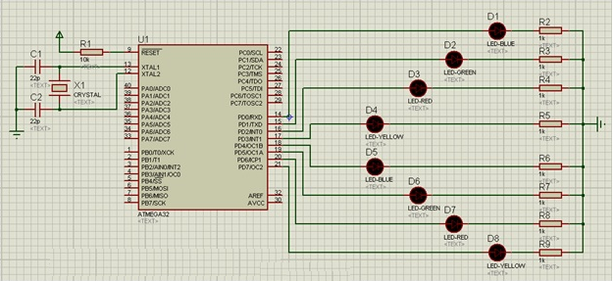

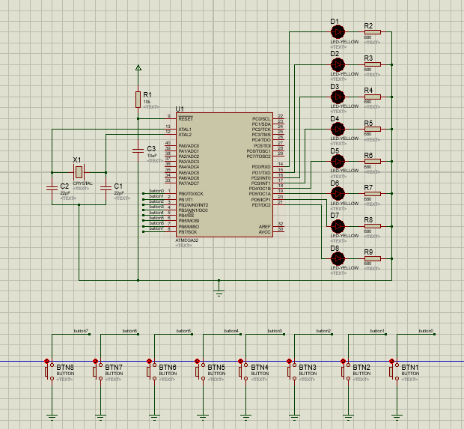
a) Draw the schematic, flow chart then write an AVR C program to toggle all the pins of Port D continuously with a 1000 ms delay. Use a predefined delay function in Win AVR.
Schematic:
+---------+
PD7 (Pin) | LED |
PD6 (Pin) | LED |
PD5 (Pin) | LED |
PD4 (Pin) | LED |
PD3 (Pin) | LED |
PD2 (Pin) | LED |
PD1 (Pin) | LED |
PD0 (Pin) | LED |
+---------+
Flowchart:
+-------------------+
| Start Program |
+-------------------+
|
v
+-----------------------+
| Set DDRD = 0xFF | <- Configure Port D as output
+-----------------------+
|
v
+-----------------------+
| PORTD = 0x00 | <- Turn off all pins (low)
+-----------------------+
|
v
+------------------------+
| Delay 1000 ms | <- Wait for 1 second
+------------------------+
|
v
+-----------------------+
| PORTD = 0xFF | <- Turn on all pins (high)
+-----------------------+
|
v
+------------------------+
| Delay 1000 ms | <- Wait for 1 second
+------------------------+
|
v
+-------------------+
| Repeat Loop | <- Go back to PORTD = 0x00
+-------------------+

#define F_CPU 16000000UL
#include <util/delay.h>
#include <avr/io.h>
int main(void)
{
DDRD = 0xFF;
While (1) {
PORTD = 0x00;
_delay_ms(1000);
PORTD = 0xFF;
_delay_ms(1000);
}
return 0;
}

b) Draw the flow chart then Write an AVR Assembly program to toggle all the pins of Port D continuously with a 1000 ms delay. Use a user define delay function. (WRONG CODE)
Flowchart:
+---------------------+
| Start Program |
+---------------------+
|
v
+----------------------------+
| Set DDRD = 0xFF | <- Configure Port D as output
+----------------------------+
|
v
+----------------------------+
| PORTD = 0x00 | <- Set Port D to low (turn off LEDs)
+----------------------------+
|
v
+----------------------------+
| Call delay_1s | <- Wait for 1000 ms
+----------------------------+
|
v
+----------------------------+
| PORTD = 0xFF | <- Set Port D to high (turn on LEDs)
+----------------------------+
|
v
+----------------------------+
| Call delay_1s | <- Wait for 1000 ms
+----------------------------+
|
v
+---------------------+
| Repeat the loop |
+---------------------+

.include "m32def.inc"

main: ; //int main(void)

LDI R16,0xFF ; DDRD = 0xFF; //PORTB is output
OUT DDRD,R16

while_1: ; //while (1) {

LDI R16,0x00 ; PORTD = 0x00;
OUT PORTD,R16

call delay_1s ; //_delay_ms(1000);
LDI R16,0xFF ; //PORTD = 0xFF;
call delay_1s ; //_delay_ms(1000);
jmp while_1

delay_1s:
LDI R20,68 ; 1 Cycle
DL3: LDI R21,100 ;
DL2: LDI R22,48 ;
DL1: DEC R22 ;
BRNE DL1 ;
DEC R21 ;
BRNE DL2 ;
DEC R20 ;
BRNE DL3 ;
RET

Problem 5:
Design an Microcontroller based system to control 8 Leds connect to 8 pin of PORTD. Each LED is connected to one pin of Port D.

- Draw the flow chart then write a C program to turn on each LED from pin D0 to pin D7 and then from pin D7 to pin D0. Call a _delay_ms(1000) function before turning on the next LED.
flow chart:
+---------------------------+
| Start Program |
+---------------------------+
|
v
+----------------------------+
| Set DDRC = 0xFF | <- Configure all pins of PORTC as output
+----------------------------+
|
v
+----------------------------+
| FOR i = 0 to 7 | <- Loop through pins C0 to C7
+----------------------------+
|
v
+----------------------------+
| PORTC = (1 << i) | <- Turn on pin C(i)
+----------------------------+
|
v
+----------------------------+
| _delay_ms(1000) | <- Wait for 1000 ms
+----------------------------+
|
v
+----------------------------+
| FOR i = 7 to 0 | <- Loop backward through pins C7 to C0
+----------------------------+
|
v
+----------------------------+
| PORTC = (1 << i) | <- Turn on pin C(i)
+----------------------------+
|
v
+----------------------------+
| _delay_ms(1000) | <- Wait for 1000 ms
+----------------------------+
|
v
+---------------------------+
| Repeat Forever | <- Go back to the first loop (i=0 to 7)
+---------------------------+

#define F_CPU 16000000UL // XTAL = 16MHZ = 8000000Hz
#include <util/delay.h> // _delay_ms(d) and _delay_us(d)
#include <avr/io.h>
int main(void)
{
char i;
DDRC = 0xFF; //PORTB is output
while (1)
{
for(i=0;i<8;i++)
{
PORTC=(1<<i);
_delay_ms(1000);
}
for(i=7;i>=0;i--)
{
PORTC=(1<<i);
_delay_ms(1000);
}

}

return 0;
}
- Draw the flow chart then write an AVR Assebly program to turn on each LED from pin D0 to pin D7 and then from pin D7 to pin D0. Using user delay_1s function before turning on the next LED.
flow chart:
+----------------------------+
| Start Program |
+----------------------------+
|
v
+----------------------------+
| Set DDRC = 0xFF | <- Configure all pins of PORTC as outputs
+----------------------------+
|
v
+----------------------------+
| MLOOP (Infinite Loop) | <- Enter infinite loop
+----------------------------+
|
v
+----------------------------+
| FOR i = 0 to 7 | <- Loop through D0 to D7
+----------------------------+
|
v
+----------------------------+
| OUT PORTC, R17 | <- Turn on LED at D(i)
+----------------------------+
|
v
+----------------------------+
| CALL delay_1s | <- Wait for 1 second
+----------------------------+
|
v
+----------------------------+
| ROL R17 | <- Rotate bits left for next LED
+----------------------------+
|
v
+----------------------------+
| Decrement R18 | <- Decrement loop counter
+----------------------------+
|
v
+----------------------------+
| Branch if R18 != 0 | <- Continue loop if R18 > 0
+----------------------------+
|
v
+----------------------------+
| FOR i = 7 to 0 | <- Loop through D7 to D0 (reverse order)
+----------------------------+
|
v
+----------------------------+
| OUT PORTC, R17 | <- Turn on LED at D(i)
+----------------------------+
|
v
+----------------------------+
| CALL delay_1s | <- Wait for 1 second
+----------------------------+
|
v
+----------------------------+
| ROR R17 | <- Rotate bits right for next LED
+----------------------------+
|
v
+----------------------------+
| Decrement R18 | <- Decrement loop counter
+----------------------------+
|
v
+----------------------------+
| Branch if R18 != 0 | <- Continue loop if R18 > 0
+----------------------------+
|
v
+----------------------------+
| Repeat MLOOP |
+----------------------------+

.include "M32DEF.INC"
LDI R16,0xFF;
OUT DDRC,R16;
MLOOP:
LDI R17,0b00000001;
LDI R18,8
L1:
OUT PORTC,R17;
ROL R17
CALL delay_1s
DEC R18
BRNE L1
LDI R17,0b10000000;
LDI R18,8
L2:
OUT PORTC,R17;
ROR R17
CALL delay_1s
DEC R18
BRNE L2
JMP MLOOP
delay_1s:
LDI R20,68 ; 1 Cycle
DL3: LDI R21,100 ;
DL2: LDI R22,48 ;
DL1: DEC R22 ;
BRNE DL1 ;
DEC R21 ;
BRNE DL2 ;
DEC R20 ;
BRNE DL3 ;
RET ;

Problem 6:
Design an Microcontroller based system to control 8 Leds connect to 8 pin of PORTC. Each LED is connected to one pin of Port C. Button 0 is connnected to PORTB.0, Button 1 is connnected to PORTB.1

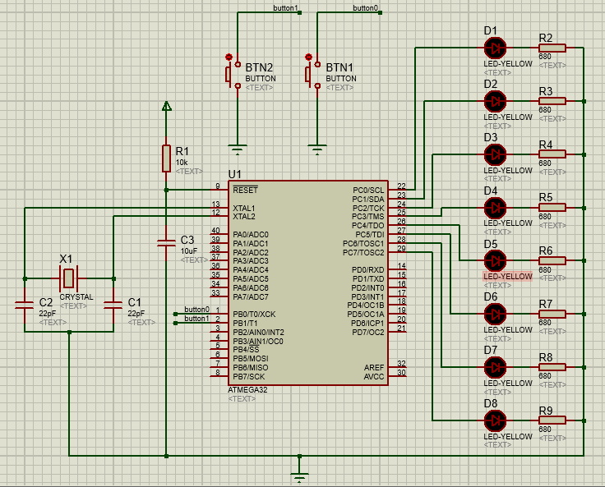
- Write a C program to read PINB.0 and PINB.1; if PINB.0 is pressed, turn on each LED from pin D0 to pin D7 (Call a _delay_ms(1000) function before turning on the next LED). if PINB.1 is pressed, turn on each LED from pin D7 to pin D0. Call a _delay_ms(1000) function before turning on the next LED.

#define F_CPU 16000000UL // XTAL = 16MHZ = 8000000Hz
#include <util/delay.h> // _delay_ms(d) and _delay_us(d)
#include <avr/io.h>
void led_patern1()
{
int i;
for(i=0;i<=8;i++)
{
PORTD=(1<<i);
_delay_ms(1000);
}
PORTD=0x00;
}

void led_patern2()
{
int i;
for(i=7;i>=0;i--)
{
PORTD=(1<<i);
_delay_ms(1000);
}
PORTD=0x00;
}

int main(void)
{
DDRD = 0xFF; //PORTD is output
DDRB =0x00; //PORTB is input
PORTB = 0xFF; // connect pull-up resistor
while (1)
{
if((PINB&(1<<0))==0)
{
led_patern1();
}
if((PINB&(1<<1))==0)
{
led_patern2();
}

}

return 0;
}

- Wrire the AVR assembly code for Question a.

#include "m32def.inc"
.def i= R19; // int i;

main: ; // int main(void)
;
LDI R16, 0xFF ; // DDRD = 0xFF //PORTC is output
OUT DDRD,R16 ;

LDI R16, 0x00 ; // DDRB =0x00; //PORTB is input
OUT DDRB,R16 ;

LDI R16,0xFF ; // PORTB = 0xFF; // connect pull-up resistor
OUT PORTB,R16
while_1: ; // while (1)
IN R17,PINB ; if((PINB&(1<<0))==0)
LDI R18,(1<<0) ;
AND R17,R18 ;
BRNE CHECK_2ND_BUTTON ; if Zero Flag=0
CALL LED_patern_1 ; // led_patern1();
JMP while_1

CHECK_2ND_BUTTON:
IN R17,PINB ; if((PINB&(1<<1))==0)
LDI R18,(1<<1) ;
AND R17,R18 ;
BRNE while_1 ; if Zero Flag=0
CALL LED_patern_2 ; // led_patern2();
JMP while_1

LED_patern_1 : ; //void led_patern1()
LDI i,8 ; //for(i=0;i<=8;i++)
LDI R16,0b00000001
LOOP_P1: OUT PORTD,R16 ; PORTD=(1<<i);
call delay_1s;
LSL R16
DEC i
BRNE LOOP_P1
RET

LED_patern_2 : ; //void led_patern1()
LDI i,8 ; //for(i=0;i<=8;i++)
LDI R16,0b10000000
LOOP_P2: OUT PORTD,R16 ; PORTD=(8>>i);
call delay_1s;
LSR R16
DEC i
BRNE LOOP_P2
RET

delay_1s:
LDI R20,68 ; 1 Cycle
DL3: LDI R21,100 ;
DL2: LDI R22,48 ;
DL1: DEC R22 ;
BRNE DL1 ;
DEC R21 ;
BRNE DL2 ;
DEC R20 ;
BRNE DL3 ;
RET

Lab 1 : Report
For problem 3,4,5,6 draw the flow chart, Analyze the function of the code, create an AVR Studio Project to Compile this Code, Design an appropriate Schematic to simulate and test this code.
(Code file : AVR Assembly GPIO Programming Example Codes_Lab1.rar)
Submit all Lab experiment evidences in the report.

